The Worshipful Company of Fruiterers’ David Hohnen & Student Prize are awarded to students for outstanding levels of dedication and achievement in the field of horticulture and fruit in particular.

The applications are assessed by leading academics and industry experts so this is a highly regarded accolade which you can add to your CV.

The winners of the David Hohnen & Student Prize:

* Receive formal recognition for their achievements
* meet potential employers and experts in the fruit and horticultural industries
* receive a prize of up to £2,500 Lauren Farwell receives the 2022 Berry Gardens Student prize at – Fruit Focus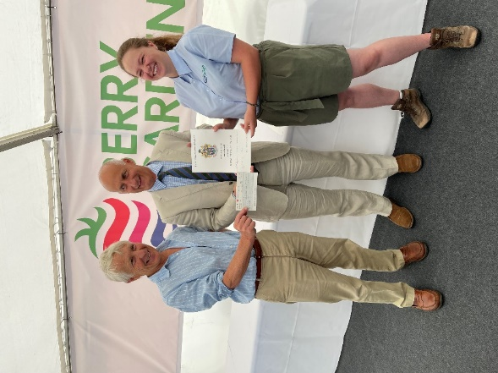

# Who can apply?

Worshipful Company of Fruiterers’ David Hohnen & Student Prize are offered via a number of institutions nationwide. There are two prizes. Current undergraduates, recent graduates, Masters and PhD students can apply. Guidelines for applicants and the criteria against which applications are assessed can be found on the Application Form. Applications should include a personal statement and a reference from the course tutor, leader or supervisor.

# What’s in the prize?

Successful students will receive a certificate, a cheque for £1,500 for the Student Prize or £2,500 for the top student and winner of the David Hohnen Prize as well as an invitation to attend Fruit Focus with fellow prize winners. This is an exciting opportunity to meet key industry leaders in the fruit sector, and to experience commercial elements of the fruit industry and its supply chain at first hand.

# How to apply?

Suitable candidates should contact their course leader or supervisor or alternatively email [awards@fruiterers.org.uk](mailto:awards@fruiterers.org.uk)

Applications, ideally by email, must be received by the Fruiterers Awards Council by 17th March 2023.

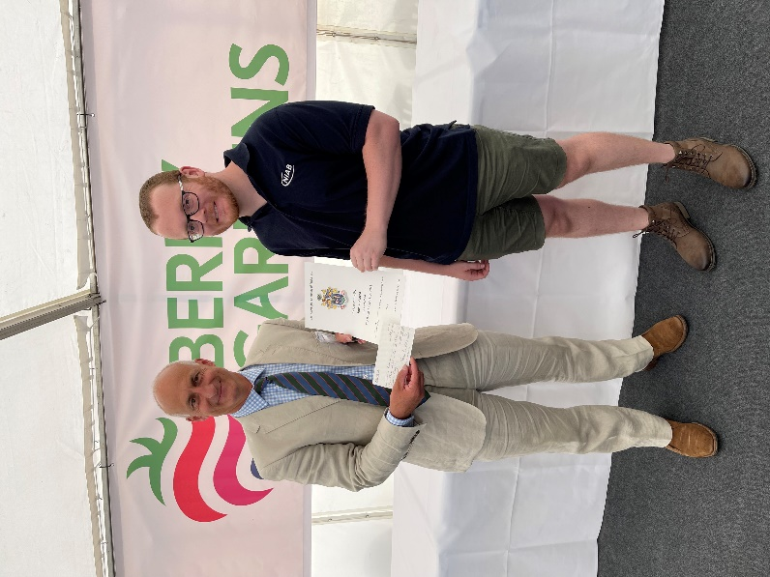

Chris Newenham, Chairman of the Awards Council presents

the 2022 David Hohnen prize to Thomas Heaven.

**About the Worshipful Company of Fruiterers**

We are a progressive City Livery Company that has been actively supporting the City of London and the fruit industry since the thirteenth century. Today over half our membership is actively engaged in the fruit industry, while the other half is drawn from a wide range of professions and occupations operating in the City and wider community. Our aim is to continue to be an influential fellowship, promoting the interests of the fruit industry, the Lord Mayor and the City of London Corporation building upon its ancient heritage and traditions.

Our key objectives are:

* + To promote excellence across all sectors of the fruit industry
  + To support education and research within the fruit industry
  + To support the Lord Mayor and the City of London Corporation
  + To be active in raising funds for charity
  + To foster, within the Livery, a spirit of good fellowship

Application Form & Guidance

|  |
| --- |
| **Full Name:** |
| **Contact details** (E-mail, telephone number and address): |
| **Institution:** |
| **Degree course:** |
| **Course leader / supervisor:** |

## Application Synopsis:

Application must include a 1,000 word summary of a research project conducted by the applicant that is of some significance to the fruit industry (nationally or internationally). The summary should include a brief introduction, a note on methodology and deliver new information or the critical analysis of a problem.

## image6.jpegThe criteria against which projects are assessed are:

* Originality and initiative
* The research question
* The approach and methodology
* Conclusions
* Value to the Fruit Industry and the Fruiterers Company
* Quality of presentation

## Personal Statement:

Applicants’ Personal Statements outlining their interests and plans for a career in the fresh produce sector and associated industries and the tutor’s or course leader’s comments will also contribute to the assessment.

Applicants are likely to be those whose research projects are well progressed or completed.

## Application submission:

Completed forms should be emailed along with any supporting work to Chris Newenham, Chairman of the Fruiterers Awards Council, at [awards@fruiterers.org.uk.](mailto:awards@fruiterers.org.uk)

## Application Deadline:

## 17th March 2023

The Worshipful Company of Fruiterers is a City of London Livery Company with a 700-year history of supporting the fruit industry. We are a charitable organisation, and our key objectives include supporting education and research, and promoting excellence across all sectors of the fruit sector.

We look forward to hearing from you and wish you best of luck with the application.